**Project Design Phase-II**

**Data Flow Diagram and Use Stories**

|  |  |
| --- | --- |
| Date | 16/10/2022 |
| Team ID | PNT2022TMID21701 |
| Project Name | Predictive Analytics for Aircraft Engines |
| Maximum Marks |  |

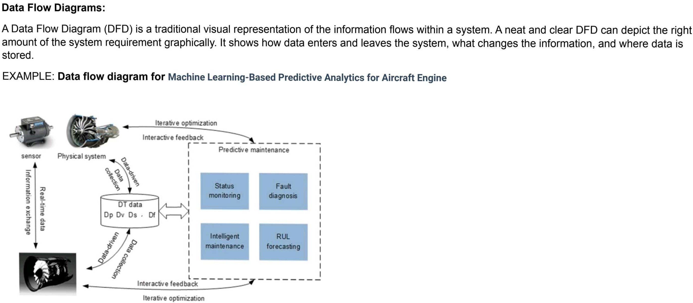

**Data Flow Diagram:**



